Newport Ventilator

Model: HT-50

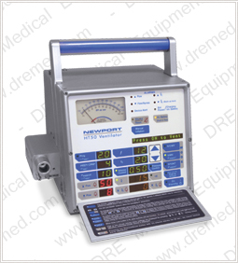

Product Description
The Newport HT50 Ventilator is the value leader in ventilatory care. With its rugged construction, easy trigger sensitivity, and fast re-charge from AC or external DC, the HT50 Ventilator is ideally suited for extended care, transport, hospital and homecare applications.
This is the ventilator you've been waiting for - compact, lightweight, unsurpassed reliability, and self contained. Its comprehensive, versatile features meet the demands of almost any healthcare setting. Suitable for both pediatric (10kg) and adult patients for invasive or non-invasive ventilation, it's easy to use and inexpensive to maintain.

FEATURES
- Volume or Pressure Control Ventilation
- Invasive or Non-Invasive Ventilation
- Pressure Support
- PEEP/CPAP, Built-in
- Comprehensive Alarms/Monitoring
- Internal Battery, long lasting with fast recharge
- Unique Gas Delivery System Requires No External Air Compressor
- Optional Air/Oxygen Mixer for high pressure 0.21-1.00
- Optional Blending Bag for Low Flow Systems

TECHNICAL SPECIFICATIONS
- Dimensions
- Width: 10.63 in (27 cm)
- Depth: 7.87 in (20 cm)
- Height: 10.24 in (26 cm)
- Weight: 15lbs (6.8kg) (w/o humidifier)
- Patient Range
- Pediatric(10 kg) - Adult
- Control Settings
- Modes (Pressure or Volume):
A/CMV
SIMV
SPONT
- Volume Control (Tidal volume): 100 to 2,200 mL
- ƒ(Frequency): 1 to 99b/min
- tl (Inspiratory Time): 0.1 to 3.0 sec
- PEEP/CPAP: 0 to 30 cmH2O/0 to 30 mbar
- Psupport (Pressure Support): 0 to 60 cmH2O/0 to 60 mbar
- V (Flow): 6 to 100 L/min
- I:E Ratio: 1:99 to 3:1
- Pressure Control (Target Pressure): 5 to 60 cmH2O/5 to 60 mbar
- P trig (Sensitivity): -9.9 to 0 cmH2O/-9.9 to 0 mbar
- Panel Lock: ON/OFF
- Manual Inflation: 3 sec maximum (single operator controlled breath)
- FIO2: .21 to 1.00
- Monitor Parameters
- Paw (Peak, Mean, Base): VT (insp. tidal volume)
- Proximial Airway Temperature: (insp. minute volume)
- Internal Battery: ƒ total (total frequency)

